Publication of an application pursuant to Article 50(2)(a) of Regulation (EU) No 1151/2012 of the European Parliament and of the Council of 21 November 2012 on quality schemes for agricultural products and foodstuffs
This publication confers the right to oppose the application pursuant to Article 51 of Regulation (EU) No 1151/2012 of the European Parliament and of the Council.
SINGLE DOCUMENT

Name: ‘’ (Skor Thnot Kampong Speu)
EC No: PGI-KH-2156 – 28/07/2016
PGI (X) PDO ( )

Name(s)
'‘’ (Skor Thnot Kampong Speu)

Member State or Third Country
Cambodia

Description of the agricultural product or foodstuff

Type of product
Class 1.8. Other products of Annex I to the Treaty (spices etc.)

Description of product to which the name in (1) applies
‘’ (Skor Thnot Kampong Speu) is made from sap of Palm sugar tree (Borassus flabellifer L.).
‘’ (Skor Thnot Kampong Speu) is characterized by a rich aroma and light brown colour like pumpkin.
There are 4 types of ‘’ (Skor Thnot Kampong Speu) produced, processed and sold on the market:
- Granulated palm sugar
- Paste palm sugar
- Block palm sugar
- Syrup palm sugar
Detailed description of the different types of ‘’ (Skor Thnot Kampong Speu)

Type | Texture | Pantone Colour  Description | Aroma | Taste | Chemical characters
Granulated sugar | - No adherent to finger  - Size of grain is or smaller than 1.5 mm  - From dry to good dry | 712 C or  713 C | The product should not smell of mushroom or burning | - Very sweet  - Taste of palm sugar from medium to strong  - There is the taste of acid and bitter very little. | Brix > 95%  pH = 4,5-6,5  Aw ≤ 0,45
paste sugar | - No adherent or adherent very little to finger  - There is crystal grain from average to many | From 131 C to  1205 C |  | - Medium sweet to very sweet.  - There is the taste of acid and bitter very little.  - The taste of palm nectar from medium to strong. | Brix= 85%-95%  pH = 4,5-6,5  Aw ≤ 0,8
block sugar | - There are crystal grains from average to substantial  - There is a little powder  - Dry to very dry | From 160 C to 712 C |  | - Medium sweet to very sweet.  - The taste of palm sugar varies from medium to strong.  - Acidity and low bitter taste | Brix = 90%-95%  pH = 4,5-6,5  Aw ≤ 0,7
Syrup sugar | - Adherent | From 712 C  To  1815 C | Medium nectar smell | - Medium sweet  - Medium palm sugar taste.  - Low acidity taste | Brix: 50-70%  pH = 3,5-6,5  Aw ≤ 0,85

Feed (for products of animal origin only) and raw materials (for processed products only)
—

Specific steps in production that must take place in the identified geographical area
1. Harvesting
Producers have to harvest the sap of the palm trees which are located in the defined geographical area.
2- Palm sap collection
The palm sap collection and processing are conducted for a period from 01 December to 31st May of the subsequent year with a specific tool, a bamboo container called a Bampong.
After taking the Bampong from the palm trees, the producers cannot pour the sap into a plastic bottle or other containers prior to processing.
Before processing, producers shall filter the palm sap by using tight strainers with a mesh of no more than 15 microns.
3- Processing (cooking) of palm sap
The processing of palm sap takes place in pans on cook stoves, no additional substances is authorised into the pans. When the evaporation has reached its target point, the pan is taken out of the stove and the product starts to crystallize and to whiten the palm sugar. Some specific tools as Antoks and Khnos are used for the processing of palm sap (traditional tools made of wood or stainless steel).
4- Palm Sugar storage
The materials used for storage of palm sugar before packaging include: Clay jar (Pottery) and Plastic container or plastic bag safe for food.
 | Granulated sugar | Paste sugar | Block sugar | Syrup sugar
Duration of temporary storage before the packaging | 3 months | 3 months | 3 months | 3 months
Duration of use  (Best before) | 3 years | 1 year | 1 year | 2 years
The palm sugar shall be stored in the following conditions:
- Dried place;
- Place not exposed to the sun light.

Specific rules concerning slicing, grating, packaging, etc. of the product the registered name refers to
After collecting and processing palm sugar, the farmers or operators shall store palm sugar for a maximum of 3 months before the packaging.
The packagers shall not use materials that could affect the quality of sugar. The proper packaging shall include:
- Packaging shall not have any chemical reaction between the packages and products.
- Packaging shall maintain product in good conditions.
- Packaging must be environment friendly (manufacturing, recycling and the transportation of materials).
Transporting ‘’ (Skor Thnot Kampong Speu) on long distances can have an impact on the aroma and quality of ‘’ (Skor Thnot Kampong Speu). In addition, packaging of ‘’ (Skor Thnot Kampong Speu) requires an understanding of the product.
The packaging of ‘’ (Skor Thnot Kampong Speu) can be done in the 3 production districts (Oudong and Samrong Tong district, Kampong Speu province; Ang Snuol district, Kandal province) or in the neighbouring districts listed below:
- Kampong Chhnang: Kampong Tralach, Sameakki Mean Chey, Rolea Bier and Krong Kampong Chhang
- Kampong Speu: Oral, Thpong, Phnom Sruoch, Basedth, Kong Pisey and Krong Chbar Mon
- Kandal: Kandal Stoeung and Ponhea Lueu
- Phnom Penh Municipality
Packaging operators of ‘’ (Skor Thnot Kampong Speu) sugar have been traditionally located in Kampong Chhang province, Kandal province and Phnom Penh municipality. They have had the expertise and know-how regarding the packaging of palm sugar products for a long time. Based on this reality and the continuity of the geographical area of the palm sap collection and processing, the Kampong Speu Palm Sugar Promotion Association (KSPA) has decided to include some districts of Kampong Chhnang province, Kandal province and Phnom Penh as packaging area of ‘’ (Skor Thnot Kampong Speu) (see also map on point 4 below).

Specific rules concerning labelling of the product the registered name refers to
The packaging and containers of the product shall bear the name of the product. The name of the GI shall appear in a font size at least as big as the biggest other letters in the packaging.
The expression ‘Protected Geographical Indication’ or ‘PGI’ shall be depicted close to the name ‘’ (Skor Thnot Kampong Speu) that may be accompanied by a translation.
The packaging must be marked with an individual batch number provided to ensure the authentication and traceability of the product. All the operators are members of the Kampong Speu Palm Sugar Promotion Association. They receive for free a member ID number which must be used as an element of the batch number.
The labelling shall also include, clearly visible, the following indications:
- The EU PGI logo
- The collective logo of ‘’ (Skor Thnot Kampong Speu) 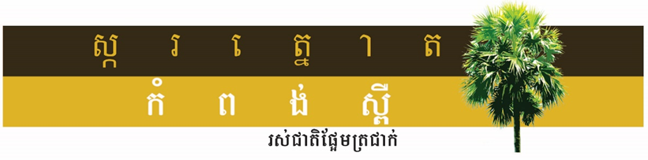
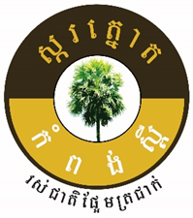

- The national logo for Cambodian Protected Geographical Indications (depicted blow)
Optionally, it may also include the logo of Protected Geographical Indication (or alike) of other countries or regions where the ‘’ (Skor Thnot Kampong Speu) enjoys a recognition of this kind.

Concise definition of the geographical area
The geographical area, dedicated to the palm sap collection and processing, consists of three districts located in the centre South of Cambodia:
- Oudong and Samrong Torng Districts of Kampong Speu province.
- Ang Snuol District of Kandal province
The packaging of ‘’ (Skor Thnot Kampong Speu) shall be done in the 3 production districts (Oudong and Samrong Tong districts, Kampong Speu province; Ang Snuol district, Kandal province) as well as in the following neighbouring districts that are listed below:
- Kampong Chhnang: Kampong Tralach, Sameakki Mean Chey, Rolea Bier and Krong Kampong Chhang
- Kampong Speu: Oral, Thpong, Phnom Sruoch, Basedth, Kong Pisey and Krong Chbar Mon
- Kandal: Kandal Stoeung and Ponhea Lueu
- 4. Phnom Penh Municipality

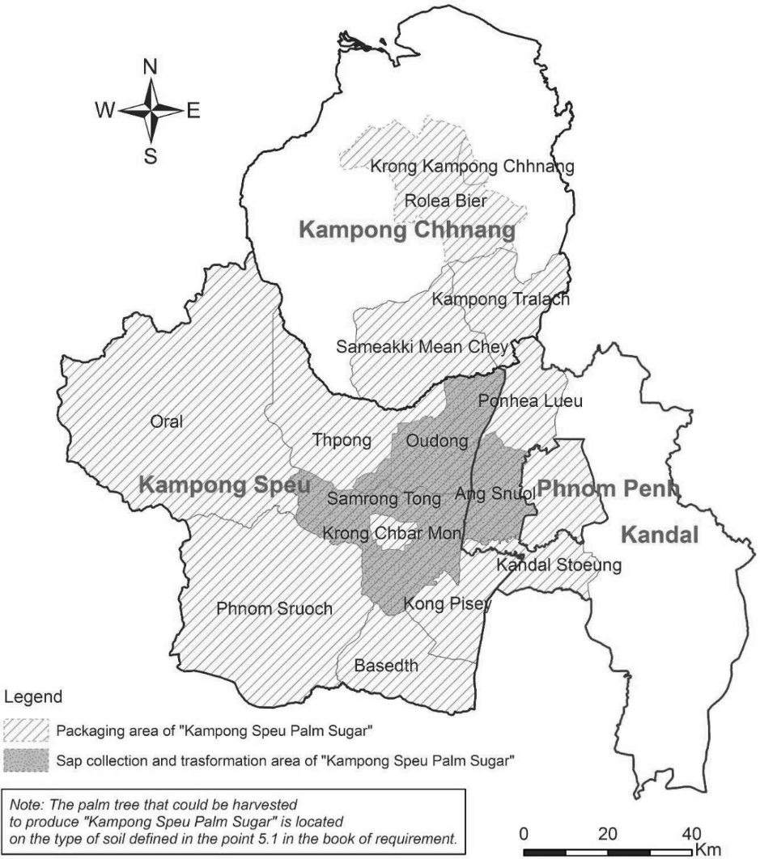

Link with the geographical area
A causal link exists between both the reputation and quality of the product and its geographical origin.
History and reputation
Sugar Palm (borassus flabellifer; Doeum Thnot in Khmer) is present in many parts of Cambodia. Farmers plant Palm trees around houses and villages, along roads, on the rice bunds around the mounds. Agricultural bibliography in Cambodia cites the year 1901 as a starting point for the expansion of the culture of the Palm sugar, with a royal order directing each farmer to plant the Borassus on his rice field. In 2005, sugar palm was recognized as the emblem of Cambodia by a Royal Decree.
In 1967, Jean Delvert, a well-known French geographer, wrote that the region of Kampong Speu was the main area of cultivation of the palm sugar with 375 000 cultivated trees (Le Paysan Cambodgien, Jean Delvert, 1961). According to Jean Delvert, in the 1950s farmers in Kampong Speu and Kandal provinces were already reputed for their expertise and know how in Palm sugar harvest: "cultivating and farming the ‘’ (Skor Thnot Kampong Speu) requires a long experience: in phum (villages), a few people know how to cultivate the thnot; "and in most areas no-one is competent: the experts in cultivating are only from the major producing regions (Kandal, Kampong Speu, Kampong Chhnang) which makes the harvest". A production of crystallized sugar from palm plant has been located in Kampong Speu since the 1970s.
The name of "Kampong Speu" is related to sugar production and palm sugar is known as a traditional production of this area. Guide books refer to the reputation of palm sugar production in Kampong Speu region notably the "Asia life guide" (article of Anita Surewicz, 01/03/2008).
Newspapers from Cambodia and from the ASEAN region regularly publish articles concerning the ‘’ (Skor Thnot Kampong Speu) such as the Phnom Penh Post (article “Palm sugar exports see 138pct rise”, 08/12/2014). ‘’ (Skor Thnot Kampong Speu) is the subject of promotional campaigns published in newspapers such as the Cambodia Daily.

Quality due to its geographical origin
The ‘’ (Skor Thnot Kampong Speu) production area is a lowland area which is not flooded during the rainy season. The average rainfall in the ‘’ (Skor Thnot Kampong Speu) production area is about 1,200 mm/year, the number of raining days is 105 days per year in average, which is considered as the lowest rainfall zone in the Kingdom of Cambodia.
Palm trees that are used to produce ‘’ (Skor Thnot Kampong Speu) are located in the districts of Oudong and Samrong Torng in Kampong Speu province and the district of Ang Snuol in Kandal province. These palm trees grow on red-yellow podzol soil, a particular type of sandy soil which is at least 80 cm deep, has a gravel layer with good drainage abilities.
Studies and analysis have shown that palm saps coming from these three districts have a high sugar concentration. All the palm sugar operators (producers, processors and local traders) acknowledge that the localization of the trees on deep sandy soils is a key factor of the quality of the sugar. The results of the analysis of palm sap coming from different districts and provinces show that in the 3 districts of the delimited production area, the sugar concentration in the sap is the highest. This explains the rich aromatic level of ‘’ (Skor Thnot Kampong Speu).
There is a clear link between the geographical area and the specific quality of the ‘’ (Skor Thnot Kampong Speu) due to a combination of several factors:
Natural factors:
- The poverty of the sandy soils of the region would give a more aromatic and more concentrated sap into sugar (2 to 3 ° Brix more than in other areas) than that of the palm trees of other provinces where the soil is richer.
- The production area has the lowest precipitation of Cambodia, which results in a more concentrated sap.

Human factors / Specific Know-how:
- The practices of producers: their expertise is involved in the management of the harvesting of the sap and in the production of the palm sugar.
The harvesting of palm sugar is done by local skilled and agile sugar producers that climb to the top of the palm trees to collect the sap from the palm flowers. The palm sap is collected only by using Bamboo container (a Bampong) because the use of plastic container is prohibited. A small piece of Popel wood or Koki wood is placed in the Bampong to decrease the speed of fermentation of the palm sap. The processing of the palm sap requires the use of typical tools such as Antok and Khnos.
The aromatic quality of the sap depends on both the number of Bampongs placed at the level of the inflorescence and on the flow of the sap. The producer can put a maximum of 1 female flower or 4 male flowers of palm tree per 1 container.
Each container is collected from the palm tree within 15 hours after they were installed, and the processing of the sap harvested starts within 2 hours after the sap is collected
Producers have a developed a specific knowledge to cook the sap in order to extract a high-quality sugar, depending on the final product they want to obtain.

Reference to publication of the specification
(the second subparagraph of Article 6(1) of this Regulation)
http://cambodiaip.gov.kh/TemplateTwo.aspx?parentId=78&menuid=230389&childMasterMenuId=230389

